METHOD FOR FINDING SHORTEST PATH IN PCBs LAYOUT VERIFICATION PROCESS
EXISTING PATENTS RELATED TO THIS INVENTION
Patent title: “Method for identifying short-circuit path in integrated circuit layout verification process”, Publication number: CN103186690 A, Publication date: 3 Jul 2013, Inventors: 王志明, 王国庆, 丁丰庆, 毛凌颖.
GOAL OF THE INVENTION
The invention disclodes a method for finding a shortest path between any two points in Printed Circuit Boards (PCBs) layout.
FIELD OF THE INVENTION
The invention belongs to the technical field of Electronics Design Automation (EDA) or Electronics Computer Aided Design (ECAD). Particularly, it relates to the field of PCB design and verification.
BACKGROUND OF THE INVENTION
EDA is a category of software tools for designing electronic systems such as Printed Circuit Boards (PCBs) and Integrated Circuits (ICs). Such tools help designer to manage the complexity of the design. To achieve that, they employ a lot of method for designing and verifying PCB designs. One of the methods is finding the shortest path between components in a PCB design. Particularly, in the PCB designs, sometime, the distance between two elements should be greater than a threshold to avoid some side effects such as crosstalk and overheating. So, the shortest path method is employed in this case to measure that distance. Our invention can be also employed in circuit routing problem which find a best path to connect components in PCB layout.
Finding the shortest path between two elements in a PCB layout can be transformed into a shortest path problem in 2D environment. In addition, because there have holes inside the PCB layout, the problem turns to finding the shortest path in polygonal domain. Our invention is constructed by using components: polygon triangulation algorithm, Dijkstra algorithm, and Funnel algorithm.
Polygon triangulation is the decomposition of a polygonal area (PCB layout) into a set of triangles. There have a lot of algorithms to triangulate a polygonal area such as ear clipping, monotone. Delaunay triangulation is another way to create a triangulation. Our invention uses constrained Delaunay triangulation algorithm for triangulate the PCB layout. The complexity of this algorithm is O(NlogN) with N is number of point constructing the PCB layout.
Dijkstra algorithm is an algorithm for finding the shortest path among nodes in a graph. In our invention, it is used to find a shortest sequence of triangles, called shortest channel, in the graph of triangles build by polygon triangulation algorithm above. The complexity of Dijkstra algorithm is O(|E| + VLog|V|) with V is number of triangles and E is number of edges in the graph of triangles.
Once we have the shortest channel from the start point to the end point, we can apply funnel algorithm on this channel. The funnel algorithm considers three structures: the path, the apex, and the funnel. The path is the series of line segments forming the portion of the shortest path. The funnel consists of two series of line segments which represent the area in which all shortest paths to the area not yet processed, must be. Finally, the apex is the point which joins the path and the funnel. The first apex starts at start point. FIG 6 shows these structures. This algorithm can be done in time linear O(T) with T is number of triangles in channel. This number is much less than number of point constructing the PCB layout.
EFFECTS OF THE INVENTION
The overall complexity of our method is in polynomial time O(NlogN). Therefore, the present method quickly searches the shortest path between any two points in PCBs layout. It adapts with the complexity of PCB layout, so that the required storage space and the running efficiency is high compare to general search algorithms.
HOW GOOD FOR BUSINESS
Verification processes in EDA tools are important because they avoid defects in design and reduce design costs. However, PCBs are becoming increasingly large and complex, typically including millions of individual elements such as ICs, transistors and logic gates. As a result of this increased size and complexity, how to complete the verification of the design within the effective time has become the major issue need to be solved. The present invention can be employed in many kinds of verification process to reduce time for verifying designs but ensuring the reliability. In addition, a modified version of our invention can be applied in routing problem.

DRAWINGS OF THE INVENTION
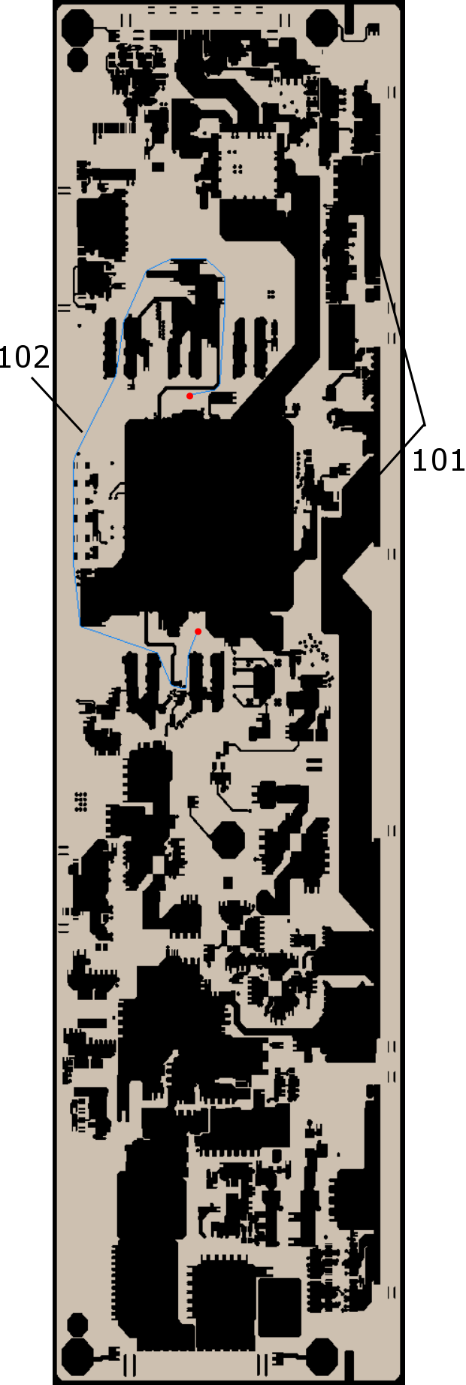
FIG. 1
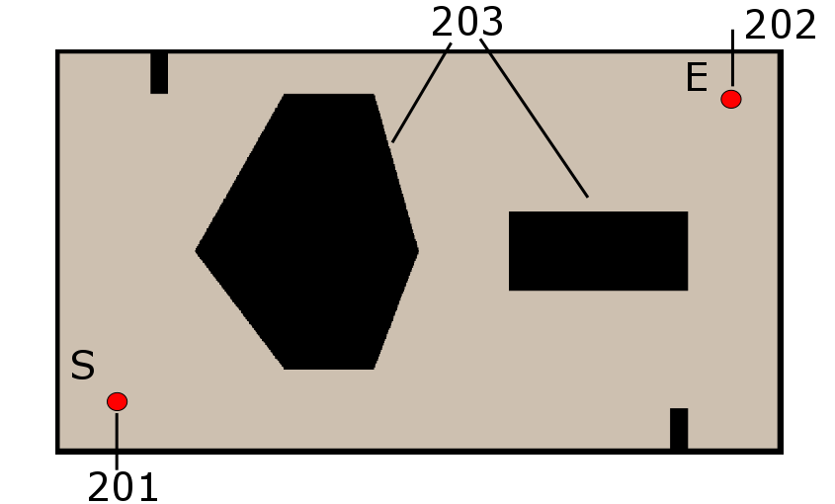
FIG. 2

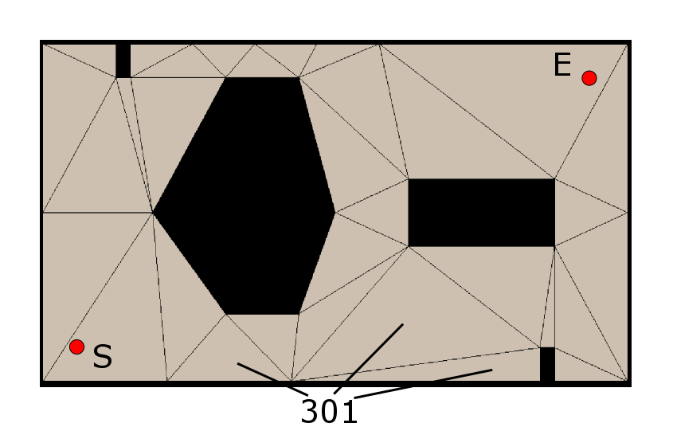
FIG. 3
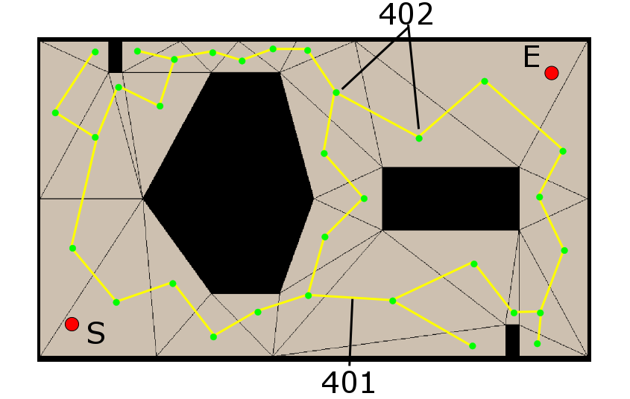
FIG. 4

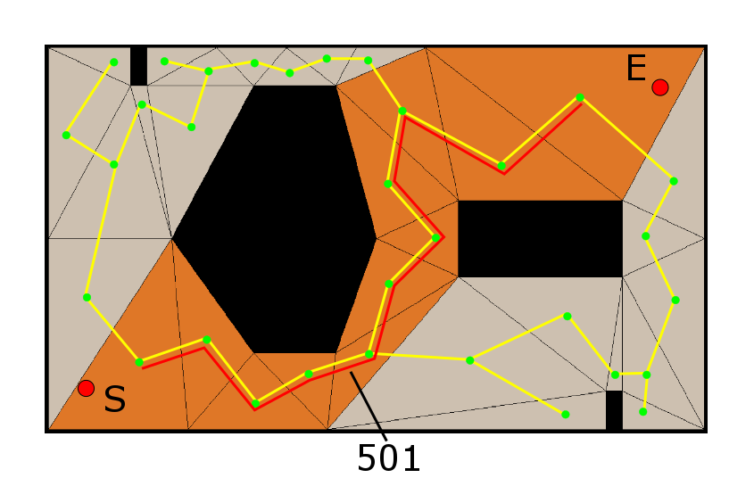
FIG. 5
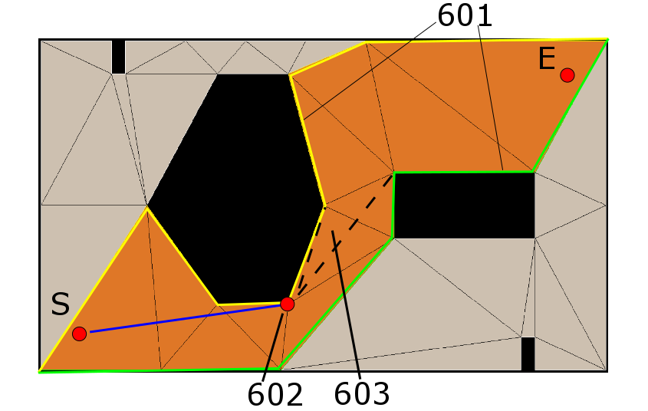
FIG. 6
ddddsdsd

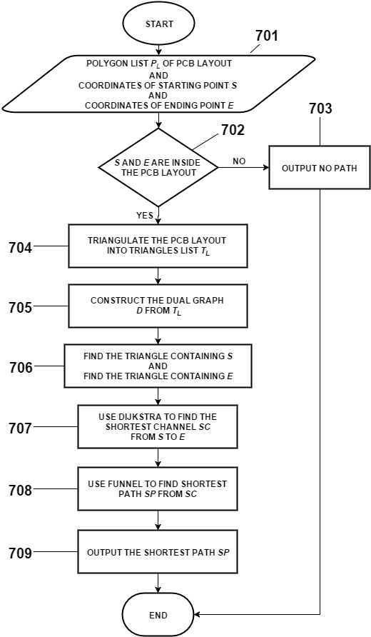
FIG. 7A
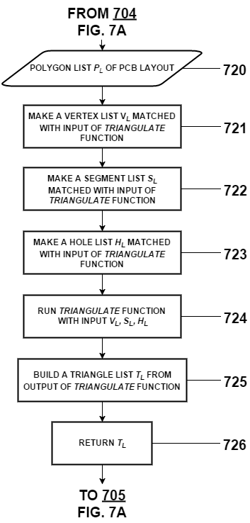
FIG. 7B

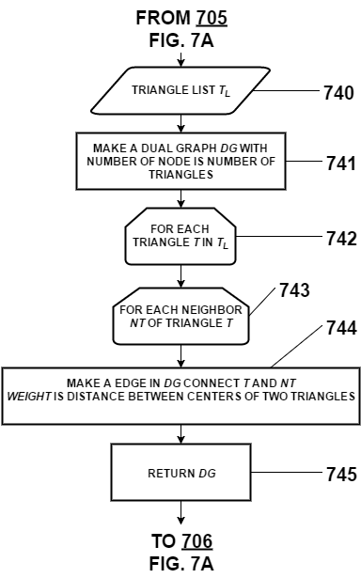
FIG. 7C

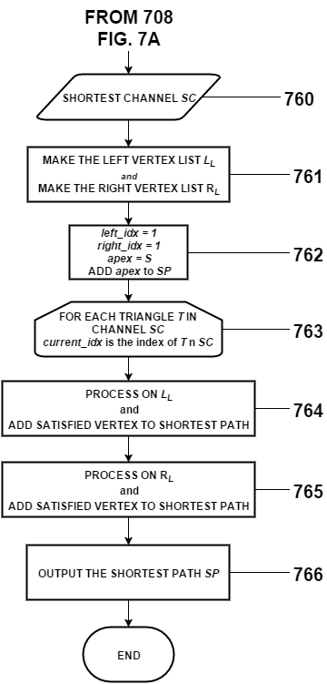
FIG. 7D

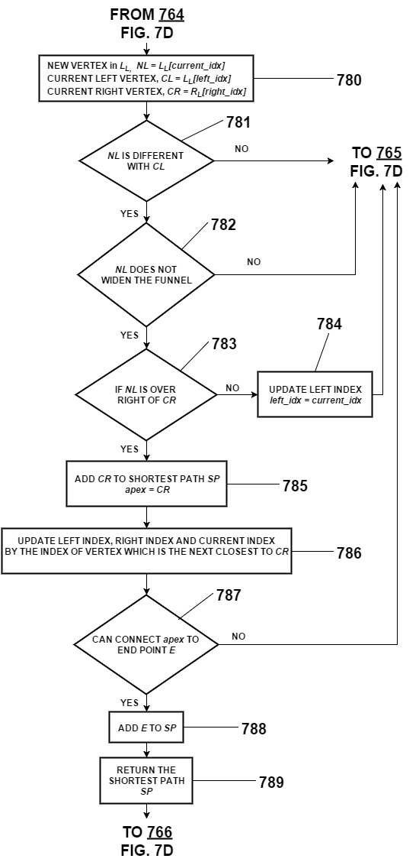
FIG. 7E
BRIEF DESCRIPTION OF THE DRAWING
FIG. 1 is a real PCB layout with a lot of holes 101 inside of it. It also illustrates shortest path 102 which is generated from our invention.
FIG 2 is a small PCB layout for easily illustrating our invention. It contains holes 20
FIG 3
DETAILED DESCRIPTION OF THE INVENTION
Dsdsdsd
THE INVENTION WE WANT TO PROTECT
1. A computer-implemented method comprising steps of:
(A) triangulate the PCB layout into triangles.
(B) construct a dual graph of the triangles
(C) use Dijkstra algorithm on the dual graph starting from at the triangle containing start point to the triangle containing target point
(D) use funnel algorithm on the channel of triangels (found in (C)) to find the shortest path from start point to the end point.
2. The method of claim 1, wherein the step (A) uses constrained Delaunay triangulation.
3. The method of claim 1, wherein the step (C) comprises steps of:
(C) (1) Determine the triangle containing the start point and triangle containing the target point
(C) (2) use Dijkstra algorithm on the dual graph.

